ABASEACA MIHAI GABRIEL ANTON GINA BALABAN-DRAGOMIR
MARIANA-CARMELIA

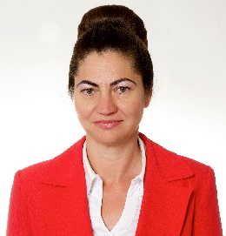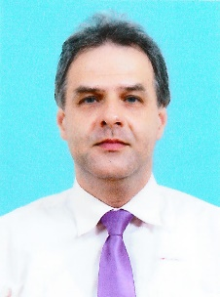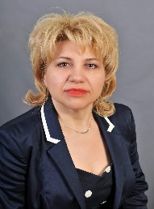
BANICA CARMEN ELENA BOTEA VIOREL BROASCA VIRGINIA GIANINA

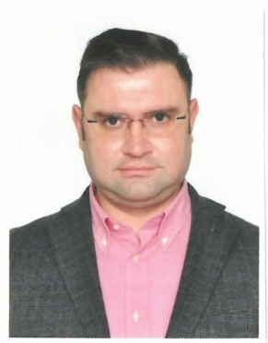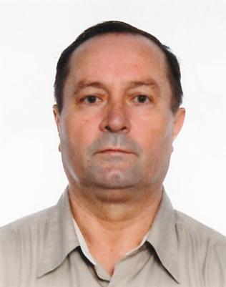
BUCALAU ALEXANDRU BURTEA FANEL CAPATINA MARIAN
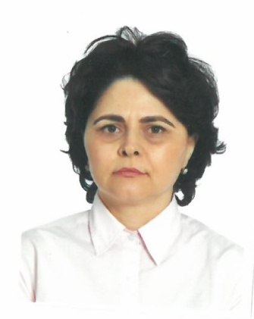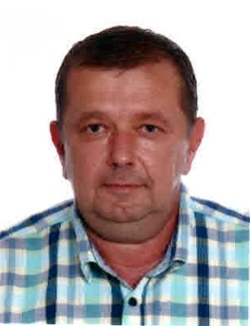
CHIVU MIRELA CIRLIGEA FLORIN EUGEN CORTEZ VASILE

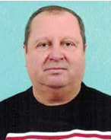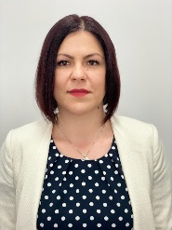
DOROBANTU STAVAREL DUMITRU AUREL GERU LAURA OANA

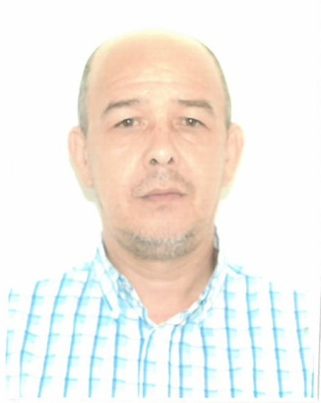
GHIORGHIU MARIAN ICHIM ANDREI IONUT ISMAIL DURAN

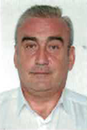
LUNGU DANUT NECOARA ANAMARIA NEGRU MARIUS-CATALIN

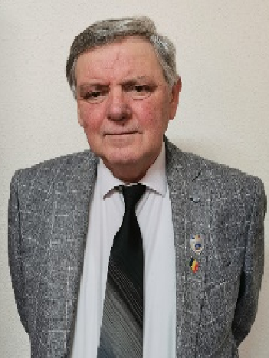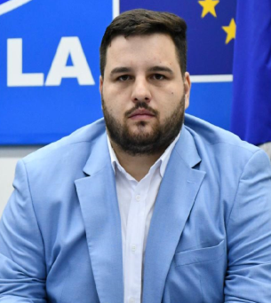
ORZARU VASILE PRICOP CRISTIAN-FLORINEL SANDU COSMIN IULIAN

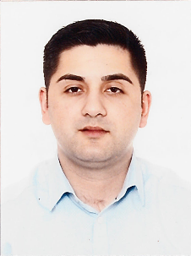
TURCOEANU VALENTINA VARGA VASILE-CONSTANTIN VILSAN DOREL
VLAD-PASCALE DANIELA-ANDREIA

